Date: 01/02/2018

University/Academic Institution: Sandip University Course Name: M.Tech ACDS

Batch Name: 2017-19 Module Name: Advanced Data Structures

Pre -Assignment: (All programs to be committed via git only)

1. Write a C++ program, which initializes a string variable to the content "The desire to learn should be stronger than the desire to live" and outputs the string to the disk file OUT.TXT. Include all the header files if required.

ANS:

CODE:

#include<iostream>

#include<fstream.h>

#include<conio.h>

using namespace std;

int main()

{

clrscr();

char text[60]="Desire to Learn should be stronger than desire to live";

fstream file;

file.open("OUT.txt",ios::out/ios::in);

file<<text;

file>>text;

cout<<text;

file.close();

getch();

return 0;

}

OUTPUT:

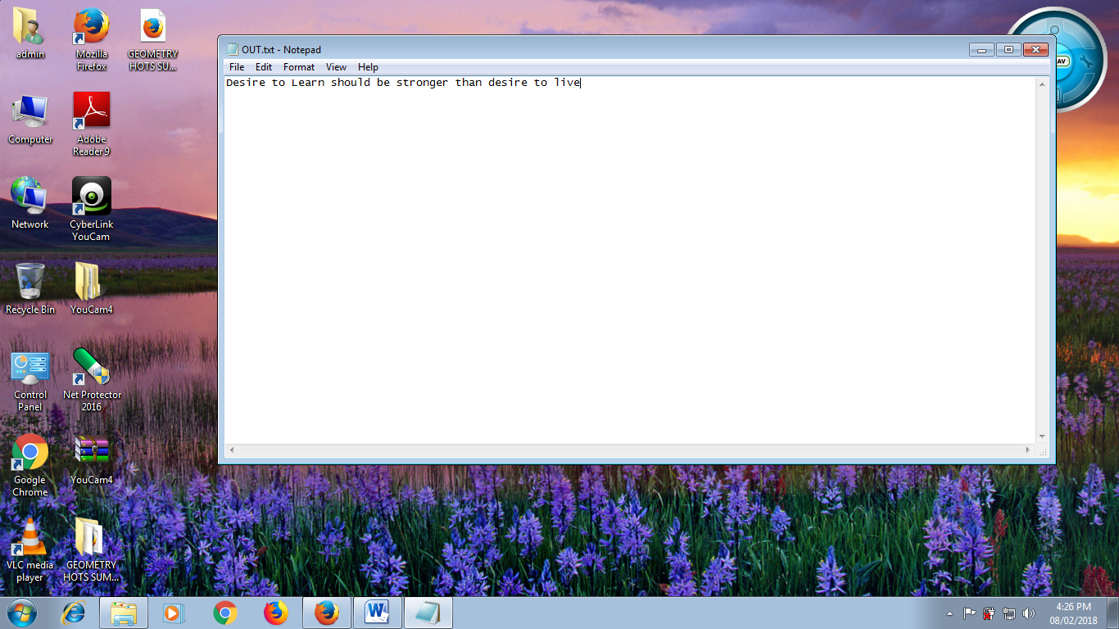

2. Declare a structure to represent a complex number (a number having a real part and imaginary part). Write C++ functions to add, subtract, multiply and divide two complex numbers.

ANS:

CODE:

#include<iostream>

#include<conio.h>

#include<math.h>

using namespace std;

struct complex

{

float rel;

float img;

}s1,s2;

int main()

{

clrscr();

float a,b;

cout<<"\n Enter real and imaginary part of 1st complex number:";

cin>>s1.rel>>s1.img;

cout<<"\n Enter real and imaginary part of 2nd complex number:";

cin>>s2.rel>>s2.img;

//Addition

a=(s1.rel)+(s2.rel);

b=(s1.img)+(s2.img);

cout<<"\n Addition: "<<"("<<a<<")"<<"+"<<"("<<b<<")"<<"i";

//Subtraction

a=(s1.rel)-(s2.rel);

b=(s1.img)-(s2.img);

cout<<"\n Subtraction: "<<"("<<a<<")"<<"-"<<"("<<b<<")"<<"i";

//Multiplication

a=((s1.rel)*(s2.rel))-((s1.img)*(s2.img));

b=((s1.rel)*(s2.img))+((s2.rel)*(s1.img));

cout<<"\n Multiplication: "<<"("<<a<<")"<<"*"<<"("<<b<<")"<<"i";

//Division

a=(((s1.rel)*(s2.rel))+((s1.img)*(s2.img)))/(pow(s2.rel,2)+pow(s2.img,2));

b=(((s2.rel)*(s1.img))-((s1.rel)*(s2.img)))/(pow(s2.rel,2)+pow(s2.img,2));

cout<<"\n Division: "<<"("<<a<<")"<<"/"<<"("<<b<<")"<<"i";

getch();

}

OUTPUT:

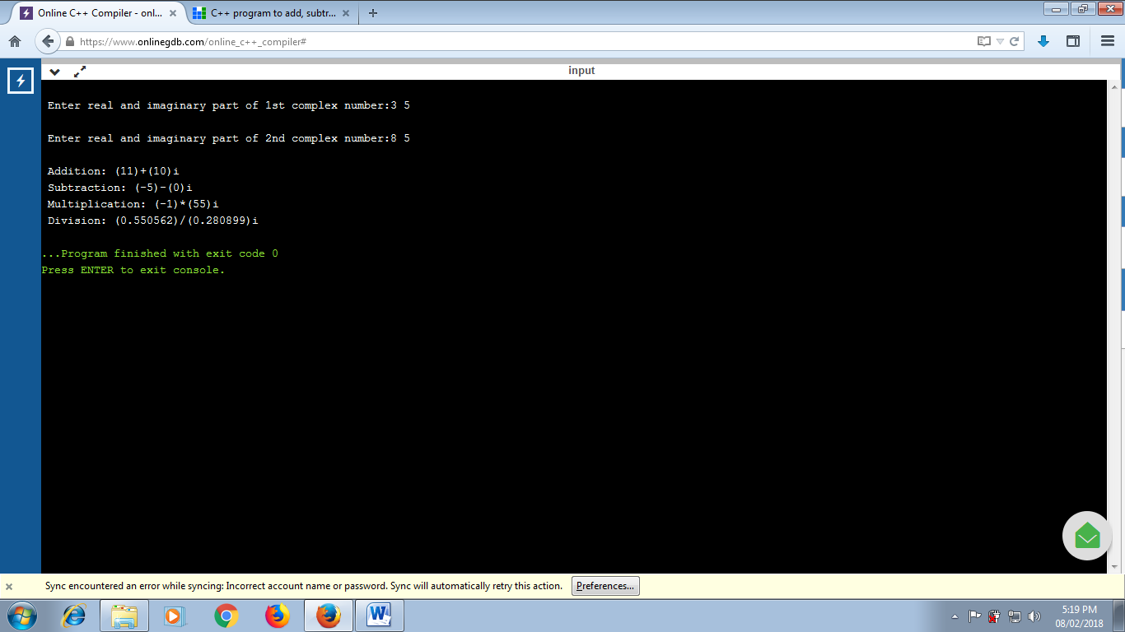

3. Write a program in C++ to swap values of two variables using pointers.

ANS:

CODE:

#include <iostream>

using namespace std;

int main()

{

int a = 11, b = 13, temp;

cout << "Before swapping." << endl;

cout << "a = " << a << ", b = " << b << endl;

temp = a;

a = b;

b = temp;

cout << "\nAfter swapping." << endl;

cout << "a = " << a << ", b = " << b << endl;

return 0;

}

OUTPUT:

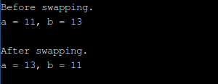

4. Write the definition for a class called **budget** that has floating point data members income and tax. The class has the following member functions:  
**void show(float, float)** to set the specified value in object **void display()** to display income and tax **void calculate ()** to calculate tax on the basis of income (Rs 10000.0) and tax rate (18.0)

ANS:

CODE:

#include <iostream>

using namespace std;

int main()

{

int pay;

int sum;

cout<<"please enter your income"<<endl;

cin>>pay;

if(pay<=180000)

{

sum=pay*0.05;

}

else if(pay>180000 && pay<=300000)

{

sum=pay*0.07;

}

else if(pay>300000 && pay<=500000)

{

sum=pay*0.1;

}

else if(pay>500000 && pay<=750000)

{

sum=pay*0.12;

}

else if(pay<750000)

{

sum=pay*0.15;

}

cout<<"your imcome tax is "<<sum<<endl;

}

OUTPUT:

